For Project 2, we used the Amazon Elastic Map Reduce (EMR) to conduct some analysis by using the Spark tools. We created a cluster and completed our analysis within the jupyter notebook.

This analysis was about exploring IMDb and finding out answers to qestions including but not limited to:

1. Number of Movies acted by Zendaya per year.
2. Movies starring Johnny Depp and Helena Bonham Carter.
3. Movies by Brad Pitt after 2010.

I have attached my cluster and notebook configuration below:

Cluster configuration:

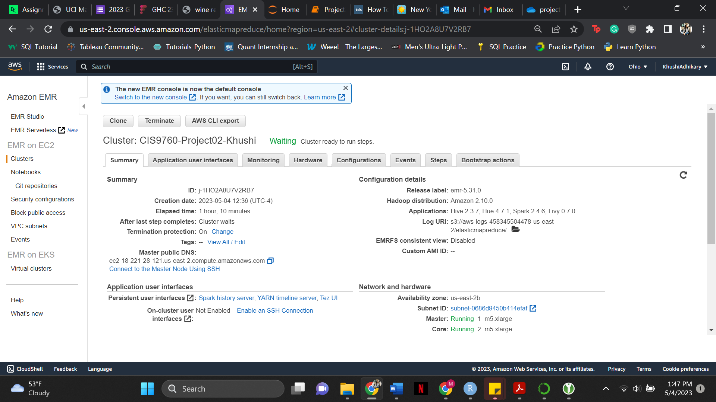

Notebook Configuration:

